**46.4. Maven Archetypes**

**Maven Archetypes**:

* Archetypes can be used to create new Maven projects
* Contains template files for a given Maven project
* Think of it as a collection of "starter files" for a project
  + Java Project, Web Project, etc.

**Common Archetypes**:

|  |  |
| --- | --- |
| **Archetype Artifact ID** | **Description** |
| maven-archetype-quickstart  (Good for standalone projects) | An archetype to generate a sample Maven project. |
| maven-archetype-webapp  (Good for web projects) | An archetype to generate a sample Maven Webapp project. |
| … others … | … |

There is another archetype out there. <http://maven.apache.org/archetypes>

**Archetypes**:

* We can create new projects using Maven Archetypes (starter project)
  + From the command-line with Maven
* From an IDE
  + Eclipse, IntelliJ, NetBeans etc.

**List of Archetypes – Eclipse (File -> New Maven Project)**:

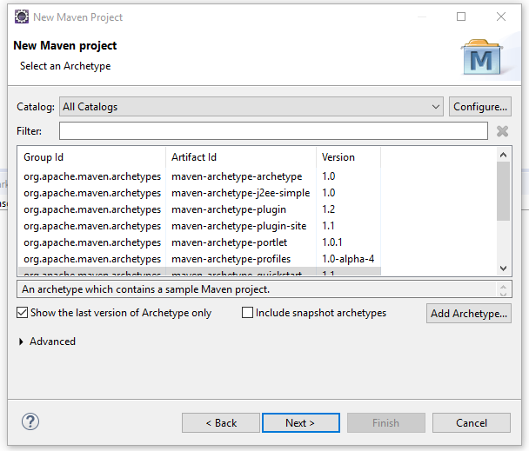

**Quickstart Archetype**:

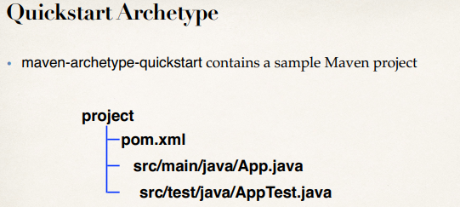

**Webapp Archetype**:

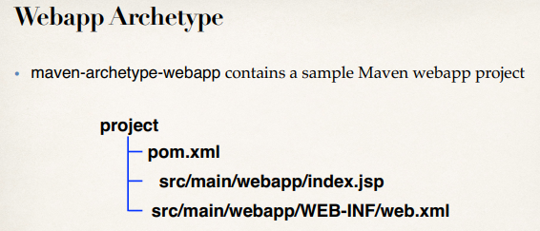

46.1. Maven Overview